POSITION TITLE
Project Manager
DEPARTMENT
Office of Student Life and Veteran Services Office
POSITION CATEGORY
Student Intern
JOB SUMMARY
The Project Manager serves as the Student Veterans of America (SVA) Chapter Vice President. Responsible for all the planning, coordination, and execution of the SVA Chapter President’s strategic plan and agenda. Advises the SVA Chapter President on all chapter matters. Liaises with CCRI Student Government Vice President. Serves as the subject matter expert relating to CCRI’s Student Life Policies & Procedures for student-led organizations. The Project Manager should have a strong business-mind and entrepreneurial nature.
DUTIES AND RESPONSIBILITES
- Advises the SVA Chapter President on strategic planning.
- Plans and coordinates the resources needed to execute the SVA Chapter President’s agenda.
- Ensures adherence to the budget, schedule, and scope of the President’s strategic plan.
- Tracks milestones and performance measurements of projects and programs in real time.
- Attends all student government and student senate meetings as an SVA representative.
- Develops rapport and a strong working relationship with the Vice President of CCRI student government.
- Participates in the annual SVA Leadership Summit on behalf of all CCRI students.
- Liaises with SVA Chapter Vice Presidents at Bristol Community College, Bryant University, Brown University, New England Tech, Rhode Island College, and the University of Rhode Island.
- Plans and develops fund raiser strategies for the SVA Chapter with the Financial Manager.
- Ensures the SVA Chapter complies with all regulations set by the college.
- Maintains the chapter’s long and short range calendars.
- Confers with key personnel on projects and programming for the SVA Chapter.
- Recruits and trains the next Project Manager.

MINIMUM QUALIFICATIONS
- One (1) academic year remaining at CCRI.
- 2.5 cumulative GPA or higher.
PREFFERRED QUALIFICATIONS
- Pursing a degree in Business Management, General Business, Communication, or any business program.
- Be a 3/4 full-time student using a GI Bill benefit to pay for school.
REPORTS TO
Reports directly to the CCRI Veteran Resource Coordinator and fully supports the SVA Chapter President. Liaises closely with the Vice President of the CCRI Student Government.
VACANCIES, LOCATION, AND SCHEDULE
One (1) position available. Can work remotely. Flexible schedule up to 25 hours per week.
WORK SCHEDULE
Schedule is flexible around academic, professional, and personal schedules. Minimum five (5) hours per week with a maximum allowable of 25 hours per week. Must attend weekly team meetings (virtual) for the SVA Chapter executive board and CCRI Student Government sessions.
FULL TIME/PART TIME
Part time.
PERMANENT/LIMITED POSITION
Limited. As available.
BENEFITS
None.
PAY
Pay available to those eligible for VA Work Study. Must be ¾ full-time AND be using a GI Bill benefit to be eligible for pay. Otherwise, available for academic credit or Honors Program projects depending on professor approval.
ADDITIONAL SALARY INFROMATION
Pay is tax free if eligible for VA Work Study. Amount is federal or state minimum wage, whichever is more.

LENGTH OF CONTRACT
VA Work Study contracts are for one (1) academic semester. The position is itself does not have a limit.
NUMBER OF VACANCIES
One position available.
APPLICATION OPEN DATE
Position opens 45 days before the start of the academic semester.
APPLICATION CLOSE DATE
Until filled.
REQUIRED DOCUMENTS
- Unofficial transcript
- Resume*
- Cover Letter*
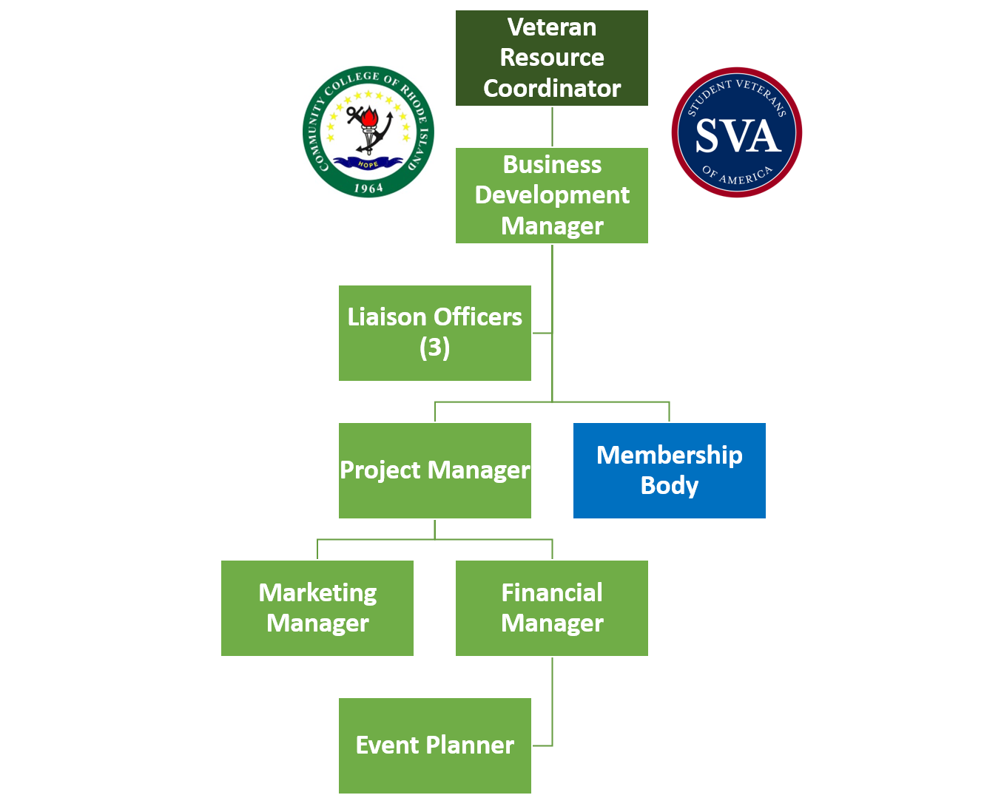
*Ensure documents are tailored specifically to this position. Schedule an appointment with Career Services for guidance.

