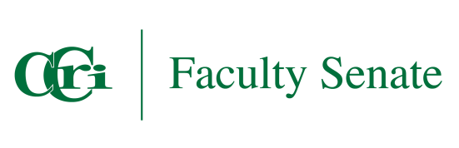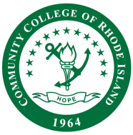

CCRI FACULTY SENATE

Student and College Success Committee
MINUTES

Date: Friday, March 7 2025
Time: 10:30 a.m.
Place: Room 4104 or via Zoom https://ccri.zoom.us/j/99793604414?pwd=8m26vubJl7Rmjok94rzf95rCJnidOt.1

Attendees: Faculty Senate and Ex-officio Members
Sen. Leslie Dolan, English, Chair
Sen. Kristine Ferro, Nursing
Sen. Robert Melucci, Math
Sen. Maria Hofman, World Languages
Sen. Ebenezer Duah, Social Sciences
Sen. Henry Chango, Adjunct Math
Rachel Rogers, Director of Center for Teaching Excellence, ex officio
Emma Montague, Dean of Student Engagement, ex officio
Greg Lapointe, Vice President for Student Affairs & Chief Outcomes Officer, ex officio

WBL subcommittee
Beth O. Anish, Dean Learning Commons & Classroom Technology, ex officio
Elizabeth R. Giordano, Director Career Services & Experiential Education, ex officio
Samantha Sgourakes, Manager Work Based Learning, ex officio

Call to Order

- Roll Call: Leslie Dolan, Rob Melucci, Maria Hofman, Rachel Rogers, Beth Anish, Liz Giordano, Sam Sgourakes

- Approval of Minutes 02/14/2025

- Old Business
  - Student Commitment Letter Update: ex officio Rachel Rogers, Senator Kristine Ferro
  - Work Based Learning, Course Designation Updates, ex officio Sam Sgourakes

  - PolicyStat Update Common Syllabus Statements and Policy Statement Update: Senator Leslie Dolan

- New Business
  - Commencement Opportunity: ex officio Emma Montague
  - Professional Development Day opportunity, April 11, 2:30-3:30 p.m., Senator Leslie Dolan
  - Committee goals for next year

VII. Adjourn

