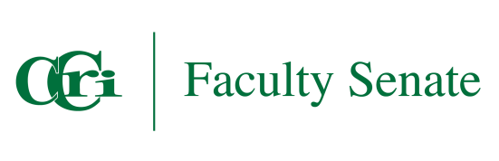

CCRI FACULTY SENATE

Online Learning
AGENDA

Date: May 2, 2025
Time: 11:00 am – 12:00 pm
Place: Zoom
Meeting Minutes
Call to Order:
Attendance:
Approval of Minutes:
Discussion Items:
- Common Syllabus Statement Policy Update:

- OLC Goal Topics Spring 2025 Status:

- Action Items:
- Action Items: Note items in blue are noted as immediate action and need to be addressed today.
  - Enhancement Statement and Link:
  - Location of Student Support Repository:
  - New OLC Chair:
  - Expansion of online learning programs:

- Other:

- Adjourn

