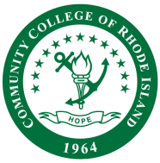

CCRI FACULTY SENATE

Online Learning
Agenda

Date: 3/21/2025
Time: 11:00 am – 12:00 pm
Place: Zoom
Members: Inglish Morgan, Soudabeh Valicenti, Justine Egan-Kunicki, Shereef Ellaboudy, Danielle Brilliant, Liz DelSesto, Mike Marripodi, Mish McIntyre

Approved Minutes: February 7th Minutes

Discussion Items

Syllabus Policy Update

Course Quality – Next Steps for OLC

OLC Goal Topics Spring 2025

