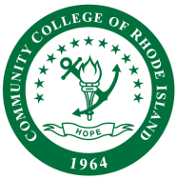

**CCRI FACULTY SENATE**

**Online Learning**

**AGENDA**

**Date**: 2/7/2025

**Time**: 11:00 am – 12:00 pm

**Place**: [Zoom](https://ccri.zoom.us/j/99330003396?pwd=HdfIVuvwEEEOfXP6GybxmdxAX5OOAu.1&from=addon)

Members:  Inglish Morgan, Soudabeh Valicenti, Justine Egan-Kunicki, Shereef Ellaboudy, Danielle Brilliant, Liz DelSesto, Mike Marripodi, Mish McIntyre

**Tentative Agenda:**

1. Call to Order
2. Roll Call
3. Approval of Minutes
4. Item I: Syllabus Policy Update
5. Item II: Course Quality – Follow-up Discussion
   1. How are we recruiting these faculty members, and what training do they need to complete?
   2. Who is responsible for confirming that a syllabus has been posted for each course?
   3. Who is responsible for confirming that a syllabus has been posted for each course?
6. Item III: OLC Goal Topics Spring 2025
   1. Item II: Course Merge – In progress
7. Adjourn