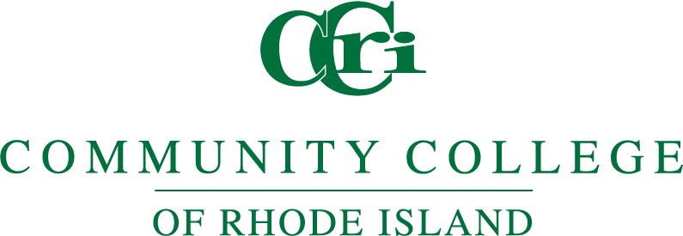

Online Learning Committee

Friday, January 24, 2025 11:00 am – 12:00 pm

Meeting Zoom Link:

Meeting ID:638 494 1076 Passcode: HMNS

Agenda

- Call to order
- Attendance
- Approval of the minutes
- Discussion Items
- Syllabus Policy Update
- Accessibility Update
- The policy on Online Course Quality includes the following: "Review of courses will be completed by online trained and certified faculty members and facilitated by the Online Learning and Technology department." How are we recruiting these faculty members, and what training do they need to complete?
- The policy on LMS Usage includes the following, "Faculty shall post a printable version of the course syllabus on the active class site in the CCRI-designated LMS. " Who is responsible to confirm that a syllabus has been posted for each course?
- The relationship between new fully online programs and existing online courses. How can we determine the quality of existing online courses that will be offered as part of new online programs?

- Other Business
  - Follow-up Re: Assessment with Lauren Webb
  - Spring 2025 Meeting Dates
    - January 24
    - February 7
    - March 21
    - April – no meeting
    - May 2nd

6. Adjourn
Next meeting...

