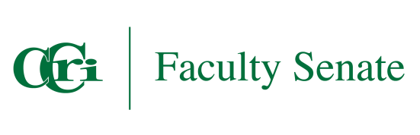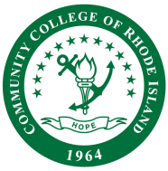

CCRI FACULTY SENATE

Online Learning
MINUTES

Date: May 2, 2025
Time: 11:00 am – 12:00 pm
Place: Zoom
Members: Inglish Morgan (Chair), Soudabeh Valicenti, Justine Egan-Kunicki, Shereef Ellaboudy, Danielle Brilliant, Liz DelSesto, Mike Marripodi, Mish McIntyre
Meeting Minutes
Call to Order: The meeting was called to order by Chair Inglish Morgan.
Attendance:
- Inglish Morgan (Chair)
- Justine Egan-Kunicki
- Mike Marripodi
- Kristen Swithers
Approval of Minutes: N/A
Discussion Items:
- Common Syllabus Statement Policy Update:
A public hearing was held on Friday, April 25, 2025, to discuss updates to the Common Syllabus Statement policy. Inglish reported that the only change recommended was to add a statement in bold lettering indicating that the repository of student support will be available in a designated location within Blackboard. Once this update is made in Policy Stat, the committee chair will present the information to the Faculty Senate on May 9th.

- OLC Goal Topics Spring 2025 Status:
  - Course Caps: The resolution relating to course caps was finalized. This item has also been addressed outside of the Online Learning Committee and is now considered "closed."
  - Course Merge: Discussions relating to the course merge were conducted via separate entity and is now considered “closed.”
  - AI and Synchronous: A discussion on the potential to include AI and synchronous options in the online learning curriculum at the College. “In Progress”.

- Action Items:
- Action Items: Note items in blue are noted as immediate action and need to be addressed today.
  - Enhancement Statement and Link: Kristen shared that leadership requested adding a statement to the Common Syllabus Policy acknowledging the 'enhancement statements' (e.g., faculty are encouraged to adapt these statements for their courses) and including a link to the Syllabus website.
  - Location of Student Support Repository: Mike informed the committee that student support items will likely be placed in the "Assist" section of Blackboard instead of the "Institution" section, allowing for easier updates. Inglish will meet with Leslie Dolan, chair of the Student Success Committee, for a Policy Stat update soon.
  - New OLC Chair: The selection of a new Online Learning Committee Chair was discussed, with a nomination for Justine. However, the final decision is on hold to consider newer members, as Justine has one year remaining on the faculty senate. This discussion will continue during the Faculty Senate Retreat in Fall 2025.
  - Expansion of online learning programs: Mike informed that his department is continuing to identify programs that are eligible as fully online. This is ongoing and will be considered for updates in the fall.

- Other: Discussion on ensuring clear lines between what is appropriate for the OLC versus discussions for the Union. Clarity on this matter will continue to be addressed as needed.

- Adjourn

