CCNA Security
Lab - Configure Clientless Remote Access SSL VPNs Using ASA-5506-X ASDM
Topology
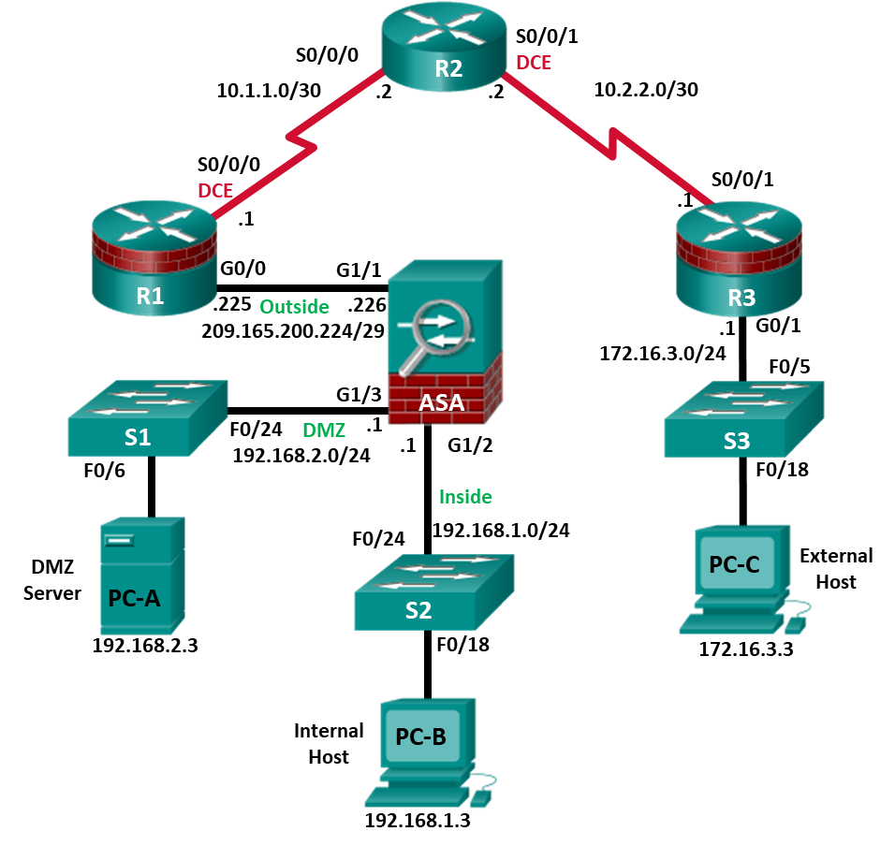
Note: ISR G1 devices use FastEthernet interfaces instead of GigabitEthernet Interfaces.

IP Addressing Table
Device | Interface | IP Address | Subnet Mask | Default Gateway | Switch Port
R1 | G0/0 | 209.165.200.225 | 255.255.255.248 | N/A | ASA G1/1
R1 | S0/0/0 (DCE) | 10.1.1.1 | 255.255.255.252 | N/A | N/A
R2 | S0/0/0 | 10.1.1.2 | 255.255.255.252 | N/A | N/A
R2 | S0/0/1 (DCE) | 10.2.2.2 | 255.255.255.252 | N/A | N/A
R3 | G0/1 | 172.16.3.1 | 255.255.255.0 | N/A | S3 F0/5
R3 | S0/0/1 | 10.2.2.1 | 255.255.255.252 | N/A | N/A
ASA | G1/1 (outside) | 209.165.200.226 | 255.255.255.248 | NA | R1 G0/0
ASA | G1/2 (inside) | 192.168.1.1 | 255.255.255.0 | NA | S2 F0/24
ASA | G1/3 (dmz) | 192.168.2.1 | 255.255.255.0 | NA | S1 F0/24
PC-A | NIC | 192.168.2.3 | 255.255.255.0 | 192.168.2.1 | S1 F0/6
PC-B | NIC | 192.168.1.3 | 255.255.255.0 | 192.168.1.1 | S2 F0/18
PC-C | NIC | 172.16.3.3 | 255.255.255.0 | 172.16.3.1 | S3 F0/18
Objectives
Part 1: Configure Basic Device Settings
- Cable the network and clear previous device settings, as shown in the topology.
- Configure basic settings for routers.
- Configure PC host IP settings.
- Verify connectivity.
- Save the basic running configuration for each router and switch.
Part 2: Access the ASA Console and ASDM
- Access the ASA console.
- Clear the previous ASA configuration settings.
- Bypass Setup mode.
- Configure the ASA by using the CLI script.
- Access ASDM.
Part 3: Configure Clientless SSL VPN Remote Access Using ASDM
- Start the VPN wizard.
- Configure the SSL VPN user interface.
- Configure AAA user authentication.
- Configure the VPN group policy.
- Configure a bookmark list (clientless connections only).
- Review the configuration summary and deliver the commands to the ASA.
- Verify the ASDM SSL VPN connection profile.
- Verify VPN access from the remote host.
- Access the web portal page.
- View the clientless remote user session using the ASDM Monitor.
Background / Scenario
In addition to stateful firewall and other security features, the ASA can provide both site-to-site and remote access VPN functionality. The ASA provides two main deployment modes that are found in Cisco SSL remote access VPN solutions:
- Clientless SSL VPN—Clientless, browser-based VPN that lets users establish a secure, remote-access VPN tunnel to the ASA using a web browser and built-in SSL to protect VPN traffic. After authentication, users are presented with a portal page and can access specific, predefined internal resources from the portal.
- Client-Based SSL VPN—Provides full-tunnel SSL VPN connection, but requires a VPN client application to be installed on the remote host. After authentication, users can access any internal resource as if they were physically on the local network. The ASA supports both SSL and IPsec client-based VPNs.
In Part 1 of this lab, you will configure the topology and non-ASA devices. In Part 2, you will prepare the ASA for ASDM access. In Part 3, you will use the ASDM VPN wizard to configure a clientless SSL remote access VPN and verify access using a remote PC with a browser.
Your company has two locations connected to an ISP. Router R1 represents a CPE device managed by the ISP. Router R2 represents an intermediate Internet router. Router R3 connects users at the remote branch office to the ISP. The ASA is an edge security device that connects the internal corporate network and DMZ to the ISP while providing NAT services to inside hosts.
Management has asked you to provide VPN access, using the ASA as a VPN concentrator, to teleworkers. They want you to test the clientless access model, using SSL and a browser for client access.
Note: The router commands and output in this lab are from a Cisco 1941 router with Cisco IOS Release 15.4(3)M2 (with a Security Technology Package license). Other routers and Cisco IOS versions can be used. See the Router Interface Summary Table at the end of the lab to determine which interface identifiers to use based on the equipment in the lab. Depending on the router model and Cisco IOS version, the commands available and output produced might vary from what is shown in this lab.
The ASA used with this lab is a Cisco model 5506-X with an 8-port integrated switch, running OS version 9.10(1), Adaptive Security Device Manager (ASDM) version 7.10(1), and comes with a Base license that allows a maximum of five VLANs.
Note: Before beginning, ensure that the ASA, routers and switches have been erased and have no startup configurations.
Required Resources
- 3 Routers (Cisco 1941 with Cisco IOS Release 15.4(3)M2 image with a Security Technology Package license)
- 3 Switches (Cisco 2960 with cryptography IOS image for SSH support – Release 15.0(2)SE7 or comparable) (not required)
- 1 ASA 5506-X (OS version 9.10(1) and ASDM version 7.10(1) and Base license or comparable)
- 3 PCs (Windows, SSH Client and Java version compatible with installed ASDM version)
- Serial and Ethernet cables, as shown in the topology
- Console cables to configure Cisco networking devices
- Configure Basic Device Settings
In Part 1, you will set up the network topology and configure basic settings on the routers such as interface IP addresses and static routing.
Note: Do not configure any ASA settings at this time.
    - Cable the network and clear previous device settings.
Attach the devices shown in the topology diagram and cable as necessary. Ensure that the routers and switches have been erased and have no startup configurations.
    - Configure R1 using the CLI script.
      - In this step, you will use the following CLI script to configure basic settings on R1. Copy and paste the basic configuration script commands listed below. Observe the messages as the commands are applied to ensure that there are no warnings or errors.
Note: Depending on the router model, interfaces might be numbered differently than those listed. You might need to alter the designations accordingly.
Note: Passwords in this task are set to a minimum of 10 characters but are relatively simple for the benefit of performing the lab. More complex passwords are recommended in a production network.
hostname R1
security passwords min-length 10
enable algorithm-type scrypt secret cisco12345
username admin01 algorithm-type scrypt secret admin01pass
ip domain name ccnasecurity.com
line con 0
login local
exec-timeout 5 0
logging synchronous
exit
line vty 0 4
login local
transport input ssh
exec-timeout 5 0
logging synchronous
exit
interface gigabitethernet 0/0
ip address 209.165.200.225 255.255.255.248
no shut
exit
int serial 0/0/0
ip address 10.1.1.1 255.255.255.252
clock rate 2000000
no shut
exit
ip route 0.0.0.0 0.0.0.0 Serial0/0/0
crypto key generate rsa general-keys modulus 1024
    - Configure R2 using the CLI script.
      - In this step, you will use the following CLI script to configure basic settings on R2. Copy and paste the basic configuration script commands listed below. Observe the messages as the commands are applied to ensure that there are no warnings or errors.
hostname R2
security passwords min-length 10
enable algorithm-type scrypt secret cisco12345
username admin01 algorithm-type scrypt secret admin01pass
ip domain name ccnasecurity.com
line con 0
login local
exec-timeout 5 0
logging synchronous
exit
line vty 0 4
login local
transport input ssh
exec-timeout 5 0
logging synchronous
exit
interface serial 0/0/0
ip address 10.1.1.2 255.255.255.252
no shut
exit
interface serial 0/0/1
ip address 10.2.2.2 255.255.255.252
clock rate 2000000
no shut
exit
ip route 209.165.200.224 255.255.255.248 Serial0/0/0
ip route 172.16.3.0 255.255.255.0 Serial0/0/1
crypto key generate rsa general-keys modulus 1024
    - Configure R3 using the CLI script.
      - In this step, you will use the following CLI script to configure basic settings on R3. Copy and paste the basic configuration script commands listed below. Observe the messages as the commands are applied to ensure that there are no warnings or errors.
hostname R3
security passwords min-length 10
enable algorithm-type scrypt secret cisco12345
username admin01 algorithm-type scrypt secret admin01pass
ip domain name ccnasecurity.com
line con 0
login local
exec-timeout 5 0
logging synchronous
exit
line vty 0 4
login local
transport input ssh
exec-timeout 5 0
logging synchronous
exit
interface gigabitethernet 0/1
ip address 172.16.3.1 255.255.255.0
no shut
exit
int serial 0/0/1
ip address 10.2.2.1 255.255.255.252
no shut
exit
ip route 0.0.0.0 0.0.0.0 Serial0/0/1
crypto key generate rsa general-keys modulus 1024
    - Configure PC host IP settings.
Configure a static IP address, subnet mask, and default gateway for PC-A, PC-B, and PC-C as shown in the IP Addressing table.
    - Verify connectivity.
Because the ASA is the focal point for the network zones and it has not yet been configured, there will be no connectivity between devices that are connected to it. However, PC-C should be able to ping the R1 interface G0/0. From PC-C, ping the R1 G0/0 IP address (209.165.200.225). If these pings are unsuccessful, troubleshoot the basic device configurations before continuing.
Note: If you can ping from PC-C to R1 G0/0 and S0/0/0, you have demonstrated that static routing is configured and functioning correctly.
    - Save the basic running configuration for each router and switch.
- Access the ASA Console and ASDM
    - Clear the previous ASA configuration settings.
      - Use the write erase command to remove the startup-config file from flash memory.
Note: The erase startup-config IOS command is not supported on the ASA.
      - Use the reload command to restart the ASA. This causes the ASA to display in CLI Setup mode. If you see the System config has been modified. Save? [Y]es/[N]o: message, type n, and press Enter.
    - Bypass Setup mode.
When the ASA completes the reload process, it should detect that the startup configuration file is missing and go into Setup mode. If it does not come up in this mode, repeat Step 2.
      - When prompted to preconfigure the firewall through interactive prompts (Setup mode), respond with no.
      - Enter privileged EXEC mode with the enable command. The password should be kept blank (no password).
    - Configure the ASA by using the CLI script.
In this step, you will use a CLI script to configure basic settings, the firewall and DMZ.
      - Other than the defaults that the ASA automatically inserts use the show run command to confirm that there is no previous configuration in the ASA.
      - Enter global configuration mode. When prompted to enable anonymous call-home reporting, respond no.
      - Copy and paste the Pre-VPN Configuration Script commands listed below at the ASA global configuration mode prompt to start configuring the SSL VPNs.
Observe the messages as the commands are applied to ensure that there are no warnings or errors. If prompted to replace the RSA key pair, respond yes.
hostname CCNAS-ASA
domain-name ccnasecurity.com
enable password cisco12345
interface G1/2
nameif inside
security-level 100
ip address 192.168.1.1 255.255.255.0
no shutdown
interface G1/1
nameif outside
security-level 0
ip address 209.165.200.226 255.255.255.248
no shutdown
interface G1/3
nameif dmz
security-level 70
ip address 192.168.2.1 255.255.255.0
no shutdown
object network inside-net
subnet 192.168.1.0 255.255.255.0
object network dmz-server
host 192.168.2.3
access-list OUTSIDE-DMZ extended permit ip any host 192.168.2.3
object network inside-net
nat (inside,outside) dynamic interface
object network dmz-server
nat (dmz,outside) static 209.165.200.227
access-group OUTSIDE-DMZ in interface outside
route outside 0.0.0.0 0.0.0.0 209.165.200.225 1
username admin01 password admin01pass
aaa authentication telnet console LOCAL
aaa authentication ssh console LOCAL
aaa authentication http console LOCAL
http server enable
http 192.168.1.0 255.255.255.0 inside
ssh 192.168.1.0 255.255.255.0 inside
telnet 192.168.1.0 255.255.255.0 inside
telnet timeout 10
ssh timeout 10
class-map inspection_default
match default-inspection-traffic
policy-map global_policy
class inspection_default
inspect icmp
crypto key generate rsa modulus 1024
      - At the privileged EXEC mode prompt, issue the write mem (or copy run start) command to save the running configuration to the startup configuration and the RSA keys to non-volatile memory.
    - Access ASDM.
      - On PC-B, start ASDM using the ASDM application or by using a browser and connecting to https://192.168.1.1 and then choosing Run ASDM.
Please refer to the previous lab for more detailed instructions.
Note: If one of the choices is Install Java Web Start, you will need to input https://192.168.1.1/admin/public/startup.jnlp in a browser if you do not want to install the Launcher.
      - After the ASDM Launcher starts, log in as user admin01 with password admin01pass.
- Configure Clientless SSL VPN Remote Access Using ASDM
    - Start the VPN wizard.
      - On the ASDM main menu, click Wizards > VPN Wizards > Clientless SSL VPN wizard. The SSL VPN wizard Clientless SSL VPN Connection screen displays. Review the on-screen text and topology diagram.
      - Click Next to continue and open the SSL VPN Interface window.
    - Configure the SSL VPN user interface.
      - On the SSL VPN Interface screen, configure SSL-VPN as the Connection Profile Name, and specify outside as the interface to which outside users will connect.
Note: By default, the ASA uses a self-signed certificate to send to the client for authentication. Optionally, the ASA may be configured to use a third-party certificate that is purchased from a well-known certificate authority, such as VeriSign, to connect clients. In the event that a certificate is purchased, it may be selected in the Digital Certificate drop-down menu.
The SSL VPN Interface screen provides links in the Information section. These links identify the URLs that need to be used for the SSL VPN service access (log in) and for Cisco ASDM access (to access the Cisco ASDM software).
      - Click Next to continue and open the User Authentication window.
    - Configure AAA user authentication.
      - On the User Authentication screen, click Authenticate using the local user database.
      - Enter the user name SSL-VPN-USER with password cisco12345.
      - Click Add to create the new user.
      - Click Next to continue and open the Group Policy window.
    - Configure the VPN group policy.
      - On the Group Policy screen, create a new group policy named SSL-VPN-POLICY. (When configuring a new policy, the policy name cannot contain any spaces.).
      - Click Next to continue and open the Clientless Connections Only window.
Note: By default, the created user group policy inherits its settings from the DfltGrpPolicy. These settings may be modified after the wizard has been completed by navigating to the Configuration > Remote Access VPN > Clientless SSL VPN Access > Group Policies submenu.
    - Configure the bookmark list (clientless connections only).
A bookmark list is a set of URLs configured to be used in the clientless SSL VPN web portal. If there are bookmarks already listed, use the Bookmark List drop-down list, select the bookmark of choice, and click Next to continue with the SSL VPN wizard.
Note: There are no configured bookmark lists by default and, therefore, they must be configured by the network administrator.
      - On the Clientless Connections Only – Bookmark List screen, click Manage to create an HTTP server bookmark in the bookmark list.
      - In the Configure GUI Customization Objects window, click Add to open the Add Bookmark List window. Name the list Web-Server.
Note: If the Web-Server bookmark list is shown as available from a previous configuration, you can delete it in ASDM and re-create it.
      - In the Add Bookmark List window, click Add to open the Select Bookmark Type window.
      - As shown in the figure, the ASDM can create three types of bookmarks. Select the URL with GET or POST method, click OK.
      - Enter the bookmark title and enter the server destination IP address or hostname as the URL to be used with the bookmark entry. In this example, the Bookmark Title of Web-Mail is entered and an internal IP address of 192.168.2.3 (the DMZ server) is specified. If this server has HTTP web services with web mail installed and functional, the outside users are able to access the server from the ASA portal when they connect.
      - Click OK to continue and return to the Add Bookmark List window which now displays the Web-Server bookmark title and URL.
      - Click OK to continue and return to the Configure GUI Customization Objects window which now displays the Web-Server bookmark.
      - Click OK to continue and return to the Bookmark List window.
      - Verify Web-Server is selected, and click Next to continue.
    - Review the configuration summary and deliver the commands to the ASA.
      - The Summary page is displayed next. Verify that the information configured in the SSL VPN wizard is correct. Click Back to make changes, or click Cancel and restart the VPN wizard.
      - Click Finish to complete the process and deliver the commands to the ASA.
    - Verify the ASDM SSL VPN connection profile.
In ASDM, click Configuration > Remote Access VPN > Clientless SSL VPN Access > Connection Profiles. In this window, the VPN configuration can be verified and edited.
    - Verify VPN access from the remote host.
      - Open the browser on PC-C and enter the login URL for the SSL VPN into the address field (https://209.165.200.226). Use secure HTTP (HTTPS) because SSL is required to connect to the ASA.
      - The Logon window should display. Enter the previously configured username SSL-VPN-USER and password cisco12345, and click Login to continue.
Note: If you were unable to log in, use the CLI to verify that the user SSL-VPN-USER is configured. If it is still not working, enter the command username SSL-VPN-USER password cisco12345 in the CLI.
    - Access the web portal window.
After the user authenticates, the ASA SSL web portal page lists the various bookmarks previously assigned to the profile. If the Bookmark points to a valid server IP address or hostname that has HTTP web services installed and functional, the outside user will be able to access the server from the ASA portal.
Note: In this lab, the web mail server is not installed.
    - View the clientless remote user session using the ASDM Monitor.
While the remote user at PC-C is still logged in and on the ASA portal page, you can view the session statistics using ASDM monitor.
From the ASDM menu bar on PC-B, click Monitoring and then select VPN > VPN Statistics > Sessions. Click the Filter By pull-down list and select Clientless SSL VPN. You should see the SSL-VPN-USER session logged in from PC-C (172.16.3.3).
Note: You may need to click Refresh to display the remote user session.
    - Log out of the web portal page.
The user should log out of the web portal window on PC-C using the Logout button when done (See Step 10). However, the web portal will also time out if there is no activity. In either case a logout window will be displayed informing users that for additional security, they should clear the browser cache, delete the downloaded files, and close the browser window.
Reflection
  - What are some benefits of clientless vs. client-based VPNs?
_______________________________________________________________________________________
_______________________________________________________________________________________
_______________________________________________________________________________________
_______________________________________________________________________________________
_______________________________________________________________________________________
_______________________________________________________________________________________
  - What are some differences when using SSL as compared to IPsec for remote access tunnel encryption?
_______________________________________________________________________________________
_______________________________________________________________________________________
_______________________________________________________________________________________
_______________________________________________________________________________________
_______________________________________________________________________________________
_______________________________________________________________________________________
Router Interface Summary Table
Router Interface Summary
Router Model | Ethernet Interface #1 | Ethernet Interface #2 | Serial Interface #1 | Serial Interface #2
1800 | Fast Ethernet 0/0 (F0/0) | Fast Ethernet 0/1 (F0/1) | Serial 0/0/0 (S0/0/0) | Serial 0/0/1 (S0/0/1)
1900 | Gigabit Ethernet 0/0 (G0/0) | Gigabit Ethernet 0/1 (G0/1) | Serial 0/0/0 (S0/0/0) | Serial 0/0/1 (S0/0/1)
2801 | Fast Ethernet 0/0 (F0/0) | Fast Ethernet 0/1 (F0/1) | Serial 0/1/0 (S0/1/0) | Serial 0/1/1 (S0/1/1)
2811 | Fast Ethernet 0/0 (F0/0) | Fast Ethernet 0/1 (F0/1) | Serial 0/0/0 (S0/0/0) | Serial 0/0/1 (S0/0/1)
2900 | Gigabit Ethernet 0/0 (G0/0) | Gigabit Ethernet 0/1 (G0/1) | Serial 0/0/0 (S0/0/0) | Serial 0/0/1 (S0/0/1)
Note: To find out how the router is configured, look at the interfaces to identify the type of router and how many interfaces the router has. There is no way to effectively list all the combinations of configurations for each router class. This table includes identifiers for the possible combinations of Ethernet and Serial interfaces in the device. The table does not include any other type of interface, even though a specific router may contain one. An example of this might be an ISDN BRI interface. The string in parenthesis is the legal abbreviation that can be used in Cisco IOS commands to represent the interface.

