A Taste Of France



Nicole Smith
Honors Project
Fall 2014
Professor Panaccione
French 1020

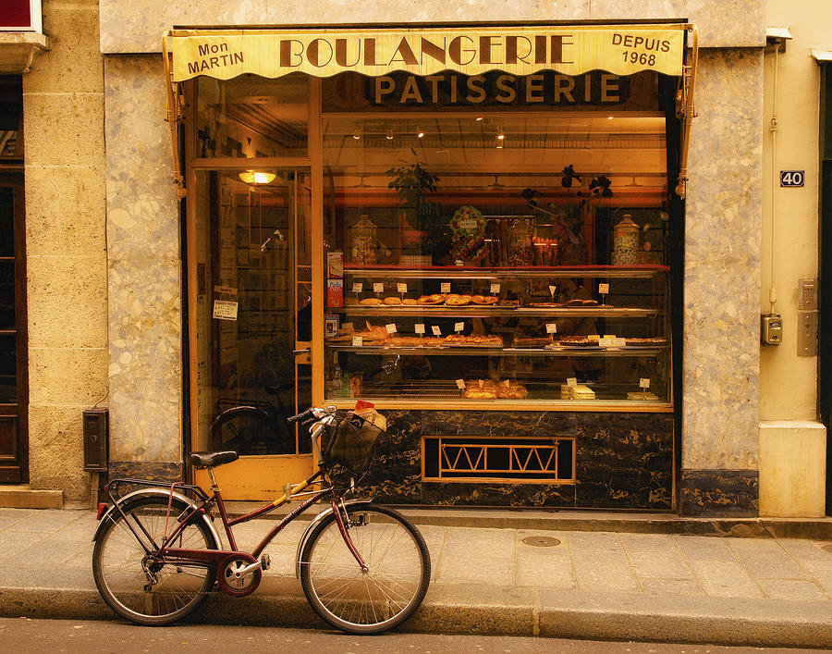
If people in America changed their eating habits to those in France, would the population see a change in obesity? When eating at a restaurant in America, people are served portions that could feed a family. Cuisine is a very important aspect of all cultures, especially French. In 1652, “Le Cuisinier François” was created as the first cookbook. The famous chef La Varenne shaped French cooking by creating this powerful cookbook (Continental Cookery). The recipes in this cookbook remain vital to French cuisine today. In many societies cuisine is overlooked as being an important aspect of culture, but it is a part of life. Cuisine should never be overlooked due to the importance it has on health. Unlike many foods in America, French food is naturally made. In America there are canned vegetables, frozen vegetables, frozen fruits, and many processed foods. Since everything is natural and freshly made in France there is a low rate of chronic heart disease (N.p).
In the French culture it was always common for people to go to each store separately to retrieve their desired foods. For bread one would go to the boulangerie, for meat the boucherie, and a separate store for les fruits et legumes. Similar to America, France has begun creating supermarkets for those who are crunched for time (“What do French People Eat”). In fast paced America, people like to get their shopping done all at once. The biggest difference with people in America, is that they are always in a rush, whereas France is famous for their long meals with many courses. It is crucial in France that cuisine is enjoyed at a leisurely pace (“Typical French Meals”).
To start the day in France, it is a small and light breakfast. At breakfast the beverage is just as important as the meal. Beverages that are enjoyed during breakfast are teas, coffees, and most commonly espresso. A simple dish that is appreciated in France, and perhaps worldwide is tartines (What do French People Eat). Tartines are fresh jam with toast. Croissants and pain au chocolat have also made their way into America. Croissants are buttery, flaky breakfast pastries, and they are often paired with coffee. Pain au chocolat means chocolate bread in English. Similar to croissants with a different shape, and they are filled with warm chocolate (History of the Croissant). As shown, in France a small light breakfast is enjoyed, but in America a big savory breakfast is normal. Eggs and bacon are the most common breakfast in America, but the people in France are disgusted by the consumption for breakfast (What do French People Eat).
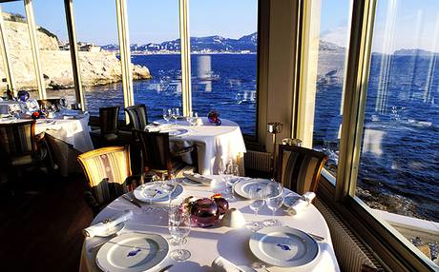
Followed by breakfast is lunch, which is the largest meal consumed in France. There are three different ways to eat lunch in France, restaurant lunch, lunch at home, and street lunch (What do French People Eat). Restaurant lunch is the most common, and it consists of a three to four course meal (French Food). Freshly made wine and cheese are always featured during a restaurant lunch (Typical French Meals). In a restaurant, the main course will be either a meat or fish paired with fresh vegetables, and potatoes (What do French People Eat). La Couple is a very famous restaurant in France, it was established in 1927. Famous for once having served Pablo Picasso, this restaurant serves fresh oysters, lobster, and other seafood’s (List). Another famous restaurant one may dine at when they are in France is La petit Nice. La Petit Nice draws customers in with its beautiful view. The chef of this restaurant created a 14- course seafood tasting meal (List). A restaurant to dine at for a special event may be Maxim’s, which was established in 1893. Maxim’s has a very artistic feel with unique lighting, coloring, and glass. Men must wear suits if they dine at Maxim’s, and it is frowned upon if women don’t wear a dress (List). With a variety of casual and dressy restaurants French restaurants appeal to so many.
Similar to restaurant lunch, lunch at home is still considered the largest meal of the day, though not quite as big as restaurant lunch. This meal consists of a warm meal with meat or fish paired with vegetables (What do French People Eat). Street lunch can be compared to lunch in America. Just like in America, people are crunched for time so they grab a sandwich on the go. The sandwiches are commonly bought from a street vendor, or from la gare. A frequently consumed sandwich in France would be cheese, or ham and cheese. These sandwiches are sometimes paired with tuna fish, salami, or hard-boiled eggs (What do French People Eat). In America we tend to have a lighter lunch that will hold us over until dinner, with some snacks in between, and it is clear that in France that is much different. Based on lunch in France, dinner depends greatly on what was consumed during lunchtime or what day of the week it is. Also similar to a meal during lunch, at dinner the meal is based around meat (Food).
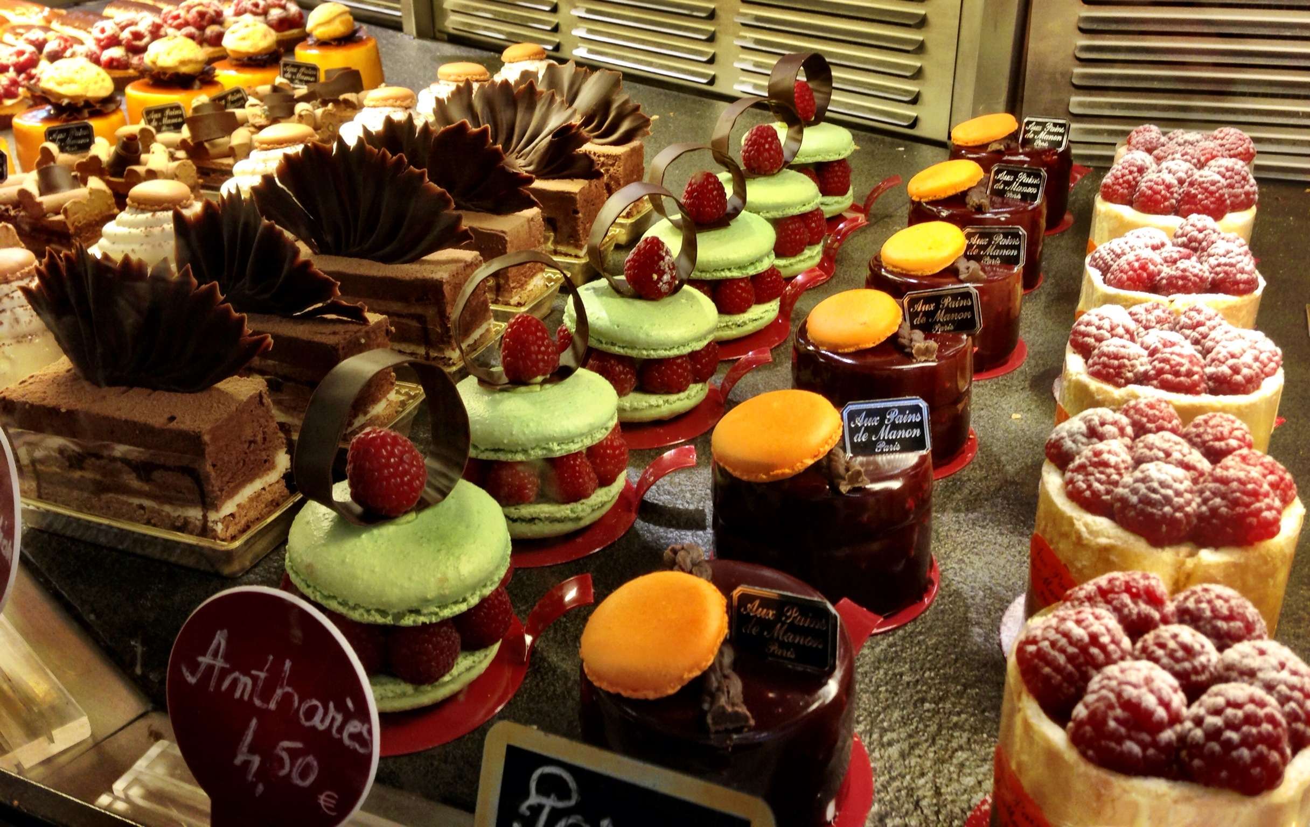
Saving the best dishes for last, French desserts are popular worldwide. Desserts in France are known for being made with French creams and French butters, making them unlike any other. Crepes are an example of a French dessert that has made its way into American society. Crepes are similar to a pancake, but much thinner. They can be savory – filled with ham and eggs for example – but for dessert they are sweet – primarily made with fruits, chocolate, and ice cream (14). Locally, in Cranston there is a restaurant called The Elephant Room, which serves a variety of different Crepes. Another famous dessert is Crème Brulee. Created in 1691 for the first time, Crème Brulee is known as a creamy egg custard (The History). Two simple desserts that are also commonly found in America are Macaroons, and Semolina. Macaroons are a simple bite size dessert, and they are made with egg whites, cream, coconut, and sugar. Semolina’s are butter cookies, and they are not baked, they are dehydrated. In America an example of Semolina would be a Lorna Doone cookie. Lastly, this dessert is not typically found in America, but it will make your mouth water. Country Apple Galette is served as a buffet style dessert, and it is a dessert pizza. This dessert is made with pastry dough, and can be filled with different types of fruits (French Desserts). As one can gather from this research, many French desserts have made their way into American societies. French desserts still stand out for their uniquely delicious fresh creams, and butters.

In France, eating a lot of dairy seems like people would be overweight, and struggle with obesity, but they portion their foods much better than we do in America. Fruits and vegetables are fresh unlike canned vegetables in America. Also, fruits and vegetables are consumed often, where as in America some people will go days without eating a fruit or vegetable. Also, in France, eating a large lunch is much better than eating a large dinner. In America eating a large dinner means one will not burn many calories after their meal, and that results in weight gain. Along with fruits, vegetables, creams, and butters being freshly made, wine is also naturally made. Drinking wine often is another positive about cuisine in France. Wine is a significant prevention against heart disease. Cuisine is a way of life for people in France. If people in America began eating, and creating foods the way people in France do, it would result in a much healthier environment.
This assignment helped me grow greatly as a student. The research I undertook for this assignment provided me with knowledge about cuisine, and the effects it may have on health. As a student, I am very devoted to my studies, and this assignment helped me realize that my hard work is noticed. Prior to completing this assignment, I was a student with very little confidence in my work. This project not only helped me grow academically, but as a person. The skills that I endured upon completing this assignment can apply to all of my other classes, and future careers. I am grateful for this opportunity, and proud of my dedication.

Works Cited
"14 Classic French Desserts." Delish. N.p., n.d. Web. 15 Nov. 2014. <http:www.delish.comrecipescooking-recipesclassic-french-desserts-recipes>.
"Continental Cookery." Recipes for Domesticity: Cookery, Household Management, and the Notion of Expertise. N.p., n.d. Web. 15 Nov. 2014. <http:www.lib.uchicago.eduewebexhibitsrecipescontinentalcookery.html>.
"Food & Eating Habits in France." Travel Tips. N.p., n.d. Web. 14 Nov. 2014. <http:traveltips.usatoday.comfood-eating-habits-france-12279.html>.
"French Desserts." N.p., n.d. Web. <http%3A%2F%2Fwww.foodandwine.com%2Fslideshows%2Ffrench-desserts>.
"French Food - Eating in France." Eating in France, Restaurants, and the French Way of Food; About-France.com. N.p., n.d. Web. 13 Nov. 2014. <http:about-france.comfood-and-eating.htm>.
"History of the Croissant." History of the Croissant. N.p., n.d. Web. 13 Nov. 2014. http:www.1-800-bakery.comnewsdeskHistory_of_the_Croissant.html.
N.p., n.d. Web. <www.frenchdesire.com%2Fau>.
"List of Famous French Restaurants in France." Travel Tips. N.p., n.d. Web. 15 Nov. 2014. <http:traveltips.usatoday.comlist-famous-french-restaurants-france-10717.html>.
"The History of Crème Brûlée | The Essential Ingredient." The Essential Ingredient. N.p., n.d. Web. 15 Nov. 2014. <http:www.essentialingredient.com.aufeaturedthe-history-of-creme-brulee>.
"Typical French Meals." Typical French Meals. N.p., n.d. Web. 15 Nov. 2014.
<http:www.1st-for-french-property.co.ukcommunityarticlesTypical-French-Meals18231925#.VGeBVv1tczY>.
“What Do French People Eat." LoveToKnow. N.p., n.d. Web. 14 Nov. 2014. <http:french.lovetoknow.comWhat_Do_French_People_Eat>.

