CCRI
The Architecture and Construction of Neuschwanstein Castle
German 1010 Honors Project
Michael Palmer
12/2/2013

Table of Contents
Introduction: 2
Ludwig ll: 2
Vision of Neuschwanstein: 4
Construction: 5
Architecture of Neuschwanstein: 9
History of Neuschwanstein after Construction: 15
Conclusion: 17
Works Cited 18

Table of Figures

Figure 1- Image of Hohenschwangau Castle 2
Figure 2- Ideal Design of Neuschwanstein Castle by Christian Jank, 1869 5
Figure 3- Image of Neuschwanstein under Construction 6
Figure 4- Image of the Singer's Hall 10
Figure 5- Image of the King's Chambers 11
Figure 6-Image of the grotto 12
Figure 7-Image of the copula of Neuschwanstein's Throne Hall 12
Figure 8-Image of the Throne Hall from the perspective of the copula. 13
Figure 9-Image of the courtyard of Neuschwanstein 14

Introduction:
The castle of Neuschwanstein (literally translated as New Swanstone Castle), is one of the most prominent castles in Germany. Located on a rugged hill above the village of Hohenschwangau near Füssen in southwest Bavaria, this castle is the culmination of the aspirations of well-known Bavarian King Ludwig ll. Every year over 1.3 million people visit this castle in order to experience its unique combination of its fantastical architecture and modern amenities. It incorporates both gothic and Romanesque architecture in order to give a visitor a romantic sense of the Middle Ages that was popular with its creator. In this report, the architecture and construction of this castle will be analyzed. Its fate after Ludwig ll’s death and the lasting impact it left on the world will also be discussed. Before this can be done, however, some background information on the life and mindset of its creator is needed.

Ludwig ll:
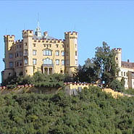
Ludwig ll of Baveria was born on August 25th 1845 in the castle of Nymphenburg (Encyclopedia Britanica). Although he was born here, Ludwig spent most of his formative years in the castle of Hohenschwangau near Füssen (fig.1). Hohenschwangau was a recently renovated castle that had been purchased by his father Maximilian II in 1829, at the time when he was still crown prince. Maximilian had stumbled upon the ruined castle while on a hunting expedition and been taken by its location and beauty. He contracted the architect Domenico Quaglio with restoring it. In particular, Maximilian wanted the theme of the swan knights that had been adopted by the previous residents of the castle as their emblem and subsequently incorporated into the castles architecture, preserved. The crown prince decorated the castle with paintings depicting the legend of the swan knight Lohengrin and other figures related to Schwangau (Knapp 7). When the rebuilding was complete the castle looked like a Mediterranean villa that was completely out of place in the mountainous region of southwest Bavaria. Nevertheless, shortly after Ludwig’s birth his entire family took up residence in the castle.
Figure 1- Image of Hohenschwangau Castle (source: Bavarian Department of State-owned Palaces, Gardens and Lakes Official Site)
Ludwig’s early education was centered on the model of Gymnasien of which foreign languages was a major part (Notable Name Database). He was taught by his father who was very strict in his lessons which resulted in a tense often distant relationship between the two. Ludwig’s relationship with his mother, Maria, was not much better. In this state, Ludwig found comfort in the mural and legends depicted throughout the castle and the trappings of being a young prince. By doing this, he gained an appreciation for art but never developed an understanding of money. His mother described his behavior, "Ludwig enjoyed dressing up … took pleasure in play acting, loved pictures and the like … and liked … making presents of his property, money and other possessions" (Bavarian Department of State-owned Palaces, Gardens and Lakes). Ludwig also developed an interest in the works of Richard Wagner during this time. The first he heard of Wagner was at the age of thirteen when he heard from a governess about Wagner’s play Lohengrin. The story of the legendary swan knight as told by the famous composer fascinated the young prince who had been surrounded by the same legend for most of his life. For the following Christmas in 1858 he received a copy of Wagner’s Opera and Drama (Knapp 9). Ludwig was taken by the story of the stalwart swan knight and the quest for redemption of Tannhäuser. He later heard both plays performed in 1861 and 1862.
This interest in the arts continued when Ludwig succeeded to the throne on March 10th 1864, at the age of eighteen (Notable Name Database). As soon as he became king, Ludwig, who had admired the composer Richard Wagner since was thirteen, invited him to Munich. During Wagner’s stay, Ludwig committed his own personal fortune in order to relieve the financial pressure that Wagner was experiencing. Over the next few years, Ludwig continued to be Wagner patron, frequently summoning him to play the piano for him in his personal residence. Over the nineteen years the two remained friends Ludwig would spend around 562, 914 marks on Wagner (King 85). This money came in the form of gifts, rent, and financing for all his operas. All of the money used for this purpose, however, came from the civil lists which was the money allocated by law for kings personal use. Nevertheless, this obsession of the king angered his cabinet who were concerned about the extent of Wagner’s influence over the king.
Early in the kings career a series of serious political disappointments forced him to admit that he had no talent in the way of politics or the day-to-day administration of a kingdom. This inability cost Ludwig greatly when the expanding state of Prussia declared war on Bavaria as part of the Austro-Prussian War. Bavaria was conquered by Prussia during the conflict. As a result Ludwig lost control of his army, was unable to make decisions regarding foreign policy, and became a vassal of the Prussian king. This was a devastating blow to the young king who retreated from court life as a result. After this time, Ludwig spent more time wandering and traveling.
In 1869, Ludwig traveled to Wartburg in Germany and visited the Mistrial’s Hall which was used as a location for Wagner’s singer’s contest in his play Tannhäuser (Knapp 11). The architecture of this place, which was connected to both Ludwig’s interest in Wagner’s plays and medieval times, fascinated him. From there Ludwig traveled though France, stopping to see the Château de Pierrefonds. The interior decorations here made a lasting impression on him that he took with him when he returned to Bavaria. When Ludwig returned, he decided to visit the area of his childhood. While wandering around, he found an area up in the hills overlooking Hohenschwangau that afforded an awe inspiring view of the surrounding country. Ludwig was captured by this scene and decided to build a castle on the spot he found much in the same way his father had done. He envisioned this new place as a refuge from the disappointments of life and as a place where he could hold unhampered sway.

Vision of Neuschwanstein:
The site where Ludwig chose to build his castle was already the site of two small ruined castles; Vorder- and Hinterhohenschwangau (Knapp 11). Like many castle builders during this time, Ludwig initially wanted to build his new castle which he called neuhohenschwangau (the name was changed after his death to Neuschwanstein) on top of the existing foundations. This proved to be impossible since the foundations were withered and unstable. Therefore, Ludwig decided to level the hill and then build the new castle. To him, the most important part of the castle was that it be a mystical structure that would not be out of place in his romanticized idea of the medieval ages. In order to accomplish this, Ludwig hired Munich scene painter Christian Jank. In a letter to Richard Wagner Ludwig laid out what he envisioned the new castle was to become:
“It is my intention to rebuild the old castle ruin of Hohenschwangau near the Pöllat Gorge in the authentic style of the old German knights' castles, and I must confess to you that I am looking forward very much to living there one day (in 3 years); there will be several cosy, habitable guest rooms with a splendid view of the noble Säuling, the mountains of Tyrol and far across the plain; you know the revered guest I would like to accommodate there; the location is one of the most beautiful to be found, holy and unapproachable, a worthy temple for the divine friend who has brought salvation and true blessing to the world. It will also remind you of "Tannhäuser" (Singers' Hall with a view of the castle in the background), "Lohengrin'" (castle courtyard, open corridor, path to the chapel); this castle will be in every way more beautiful and habitable than Hohenschwangau further down, which is desecrated every year by the prose of my mother; they will take revenge, the desecrated gods, and come to live with Us on the lofty heights, breathing the air of heaven” (Bavarian Department of State-owned Palaces, Gardens and Lakes)
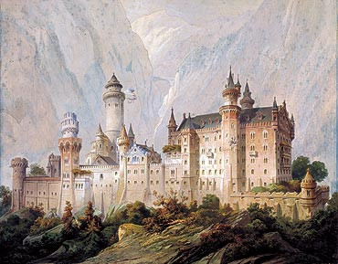
Jank was given the task of drafting a design that would fit this grand vision. The design he came up with was based heavily on Wartburg. It used a mix of Romanesque and Gothic architecture punctuated by towers inspired by those at the Château de Pierrefonds (fig 2). In his drawings, Jank heavily favored the Gothic style of architecture with its delicate details and ethereal lighting. When these drawings were given to Ludwig, though, he changed many of the features into the Romanesque style. The resulting design resembled Hohenschwangau but had distinct features that made it stand apart.
In order to translate the design of Neuschwanstein created by Jank and Ludwig into drawings that could be used to construct the castle, an architect, Eduard Riedel, was commissioned. More than anything Ludwig wanted his castle to be a refuge far up in the hills of Bavaria but the designs he gave Riedel were far from workable drawings.
Figure 2- Ideal Design of Neuschwanstein Castle by Christian Jank, 1869 (source: Bavarian Department of State-owned Palaces, Gardens and Lakes Official Site)

Construction:
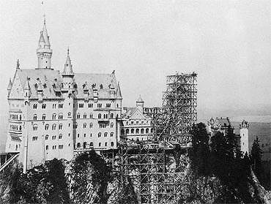
After Riedel made a series of changes to the plans for the castle, construction began in the summer of 1868. In order to build the massive castle on the hill Riedel had to remove the old ruins and level the two summits of Neudeck. It is estimated that he removed eight meters of stone outcropping to make a level surface on which to construct a foundation (Bavarian Department of State-owned Palaces, Gardens and Lakes). A service road had to be built so that materials and laborers could make it the more than 200 meters to the hills summit. Water was also needed on the construction site. To obtain this water, a spring from the Poltat valley in Bleckenau was diverted and piped down to Neudeck (Knapp 11). The river still flows to the castle today, making it self-sufficient. Once the road was built limestone which was used to face the outer wall was brought in from the nearby Alter Schrofen quarry down by the Schwansee. Brick and stone were brought in for the walls and foundation respectively. All building materials were drawn up by horse drawn carriages or horse drawn sleighs in the winter. Hundreds of masons, laborers, and craftsman worked on the castle at the same time.
The foundation stone was laid in 1869 (Knapp 11). From there work began on the walls and gatehouse. During the course of construction Riedel made use of the most advanced civil engineering techniques and the most modern technologies. The bricks that made up the wall were placed by steam powered cranes and adhered together with cement. The perimeter of Neuschwanstein was always ringed by sturdy scaffolding as workers had to lime wash by hand the exterior of every building constructed (fig 3). Some of the larger buildings of the castle were also made with iron T girders, a recent and not well understood building material at the time.
Figure 3- Image of Neuschwanstein under Construction (source: Bavarian Department of State-owned Palaces, Gardens and Lakes Official Site)
The first building erected was the gatehouse which was constructed at a right angle to the end of the road that spiraled upward on retaining walls. Ludwig held the topping out ceremony on 11 June 1872. The gatehouse was not ready for inhabitance until the next year. At this time, Ludwig made drastic changes to the plan for the castle imposing a more Romanesque type of architecture to the buildings under construction. This would become a recurring theme over the course of construction. Ludwig would spontaneously change the plans of different buildings at it suited him. He would do this even to buildings that were already under construction. These constant changes lengthened the time of construction and added to the cost but Ludwig seemed unfazed by this so long as his dream was still in progress.
When the interior of the gatehouse was finished, Ludwig took up residence there in the opulently furnished rooms when he wished to oversee the progress that was being made on the castle (Bavarian Department of State-owned Palaces, Gardens and Lakes). The residential tract at the end of the long artificially created plateau was the next project to be started. A gigantic timber-framed construction was extended over the precipice and a large steam powered crane, the largest in Germany at the time, was used to lift up building materials brought in on the road and place them into railborne vehicles to be used by workers inside (Knapp 13). The residential tract had to be slightly buckled, however, because of its massive length in order to maintain its integrity. Riedel used this tilt in the axis as an opportunity to obscure the tract by placing a trapezium-shaped space that ran diagonally through the main residential tract which served as an access hallway for a series of rectangular rooms that were installed later. This construction also served as an efficient spatial break and was the starting point of two stairwells, one was a large spiral staircase tower reserved for the king, and the other was smaller staircase tower for servants that was placed near the mountain side. A third stairwell made entirely of oak was placed in the interior of the building where it also served to obscure the residential tract from the valley side. Ludwig insisted that this tract be constructed strictly in the Romanesque style.
The Palace was the next building to be worked on, with construction commencing in September 1872. While the original plans for the Palace that were drafted by Riedel called for the building to be three stories, Ludwig insisted that it be a full five stories tall. To support the massive weight of this building the supporting walls were constructed of brick with white limestone used merely as cladding. On the interior side the brick was covered with paneling and painted over. Only the interior decorative arches were actually made of stone.
New construction techniques needed to be created in the construction of this building and parts of its interior were primarily constructed with an expansive iron T girder network. Most of the time these beams were oversized since their strength was not known at the time. This was especially true in the throne room which featured a dome modeled after the one on Hagia Sophia. This dome was supported by an iron lattice due to its weight and the weight of the ornamentation placed upon it. To construct the lattice Reidel ran large T girders across lengthwise and widthwise to form a grid. These were riveted together and smaller beams were used to bridge the gap between them. The masonry semicircle of the apse then sits atop this, while the open spandrel between the apse and the outside wall is covered with corrugated iron (Knapp 15). In this way the dome could be supported during construction without the need for extensive scaffolding and bear more weight than it would have been able to if it were constructed using the traditional techniques of the time..
On the 29th of January 1880 the topping out ceremony for the Palace was held but the interior fittings were not finished until mid-1884. At this time, construction began on the Ladies’ Bower and the Square Tower. Ludwig would not live to see the completion of the structures, however. In 1886, just three days after a psychiatrist retained by the Bavarian nobility declared Ludwig certifiably insane and therefore unfit to rule he died. Ludwig was found drowned in the Starnberger See, along with his doctor von Gudden who had certified him insane (Encyclopedia Britanica). With his death the force that was shaping the construction of Neuschwanstein was gone.
Around the same time, Rediel was replaced with another architect named Georg von Dollmann who himself was later succeeded by Julius Hofmann. Dollmann and later Hofmann were tasked by Ludwig’s successor with completing the castle quickly and with the least expense possible. By the time Rediel had been replaced many citizens of Bavaria, including both the nobles and peasantry, were upset at the money and resources the deceased king had poured into the construction of the castle. A few wanted the construction of the castle to be abandoned but enough funds and time had been invested in the undertaking that it was decided to finish the castle and then open it to the public in an effort to recoup some of the construction funds. This task fell in turn to the architects that replaced Rediel.
At this time the two main buildings that were still under construction was the Bower and the Square Tower. Dollmann and Hofmann completed these two buildings according to the plans laid out by Rediel with a few exceptions. In order to save time and money many of the intricate and eclectic features intended for the towers were replaced by repetitive and simplified versions. Construction on the tower and Bower were finished in 1892 and the castle was opened to the public (Bavarian Department of State-owned Palaces, Gardens and Lakes).
The finished Neuschwanstein was full of the latest technological innovations of the time. During his life Ludwig had insisted that the castle be outfitted with all the modern luxuries available to him. These included a telephone line in a time that telephones were still a rare commodity, elevators, hot and cold running water in the residential tract, and humidifiers which filled the castle with comfortably moist air through a network of vents built into the walls. Central hot-air-heating was installed in the rooms adjacent to the kitchen. The kitchen itself was made with the most modern appliances. Beside a free-standing large kitchen stove, whose smoke was drawn off through the ceiling into a fireplace used for heating, there stands a multi-story charcoal grill (Knapp 13). A warming cupboard for dishes sits adjacent to this. The center of the room is dominated by two automatic revolving spit arrangements where the spits, placed one above the other were rotated by means of lateral chains powered by a hot-air turbine. An intercom system was also installed throughout the castle so that Ludwig could call for his servants without a pull chain. Much of this technical equipment was hidden behind the many murals and tapestries of Bavarian history and legends Ludwig had covering the walls or were tucked away into the corners of the castle.

Architecture of Neuschwanstein:
Neuschwanstein is considered to be one of the most marvelous architectural feats and the best example of the Medieval Romanticism style of architecture. In particular, the Singer’s Hall, Study, King’s Apartment, Salon, and the Throne Room are considered to be masterpieces of both art and architecture. While these rooms are true marvels, beautiful architectural features and artwork are spread-out through the entirety of the castle.
The first floor of the residential tract, which had the same floor plan as the floors above, was reserved for servants. There was a vaulted passageway located on the valley side with two parallel suites next to it. In these rooms, the walls were covered in decorative paneling and large expensive furniture was placed along the walls. The ceilings of these rooms and of the entire floor were covered with decorative paintings that anticipate Art Nouveau in some of their details (Steinberger 30).
Through the ribbed vault passageway on this floor is the Royal Spiral Staircase which terminates on the upper floor in a round temple surrounded by columns (Steinberger 36). At the end of the flight of stairs sits a large stone dragon with its maw open wide in a silent roar. This statue guards the entrance to the anteroom of the Singer’s Hall. Next to it the newel of the staircase, shaped like the trunk of a tree, rises to the ceiling where it opens with branches covered in leaves and dates. The green fronds of the date palm blend seamlessly with the nocturnal blue of the ceiling which is studded with golden stars. This feature, reminiscent of the eagle capitals at Wartburg looks out of place as they more closely resemble the Art Nouveau style than the Romanesque architecture that dominates the rest of the castle (Knapp 13). Further on from the staircase, the Singer’s Hall takes up the whole of the fourth floor on the eastern side of the Palace.
The Singer’s Hall was one of the king’s favorite projects and was based upon the Singer’s Hall and the Festival Hall located in the Wartburg. It was in the Singer’s Hall in the Warburg that the Singer’s Contest, featured in Richard Wagner's opera Tannhäuser, was held (Knapp 15). The Hall in Neuschwanstein heavily features depictions of this contest as well as the legend of Parsifal in murals that line the walls. On the western side of the hall, separated from the rest of the room by three arcades sits the Singer’s Bower that Ludwig dreamed would be the backdrop to one of Wagner’s Tannhäuser operas. The bower is painted to resemble a forest scene which closely mimics depictions of the sacred forest that surrounds the Castle of the Holy Grail. The mural ends with an image of Lohengrin, the Swan Knight, who was Parsifal’s son. Above the mural on the coffered ceiling are the signs of the zodiac (Bavarian Department of State-owned Palaces, Gardens and Lakes).
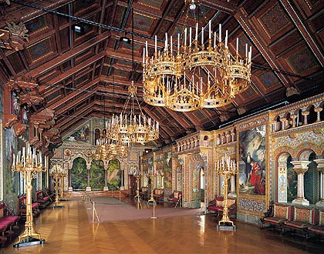
A gallery runs down the north side of the room. On the walls here Flayetanis and Kyot, the authors or translators of the Grail saga are depicted. Behind the retaining wall on this side is a passage with a colored coffered ceiling painted with scrolls that bear the names of minnesingers (Steinberger 109). Over on the opposite side of the room are carved depictions of the characters from the Parsifal legend. The Winged Lucifer, who it was said lost a stone from his crown when he fell from heavens which would later become the material used to create the Holy Grail, is featured prominently here. From the ceiling above, many gold plated chandeliers hang on black ropes to illuminate the room. The other sources of light come from gold-plated candelabra that sit on the floor and three large windows on the north side. These windows have unusually large panes of glass, which is a recurring feature throughout the castle, so they let in significantly more light than the traditional windows of the time (Knapp 13). The light passing through the intricately decorated room and reflecting off the many golden objects therein lend an ethereal and mystical feel to the room (fig. 4).
Figure 4- Image of the Singer's Hall (source: Bavarian Department of State-owned Palaces, Gardens and Lakes Official Site)
One floor directly below the Singer’s Hall in the southeastern portion of the 3rd floor of the Palace is the King’s apartment. The most magnificent room here is the King’s chambers which was one of the first rooms in the Palace to be finished (fig. 5). This room unlike most of the castle was designed primarily in the Gothic style. Its designer, Peter Herwegen wished to make the room stand out from the rest of the castle by designing it using another style rather than the Romanesque and Byzantine style that dominates the rest of the castle. The most striking feature in the room is the large ornate bed, which was done in neo-gothic style (Bavarian Department of State-owned Palaces, Gardens and Lakes). The seat coverings are done in blue silk, with embroidered and appliquéd lions, swans, crowns, lilies and the Bavarian coat of arms. The wood of the bed was intricately carved by hand over a period of four and a half years by seventeen separate wood carvers. Next to the bed sits a reading chair and washstand with a private chapel adjacent to that. The washstand although it may appear unremarkable was made in the swan theme that permeates the castle. The silver plated fountain is made in the shape of a swan and images of small swans decorate the washstand set; water jug, sponge and soap containers (Knapp 15). Near the washstand is a balcony that overlooks the waterfall of the ravine outside. The walls of the bedroom are covered in murals depicting the legend Tristen and Isolde.
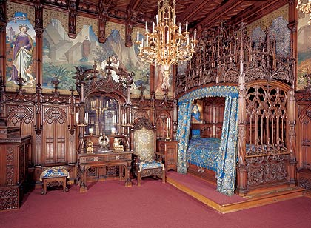
The inside wall of the bedroom is adjacent to the stream that was diverted to sustain the castle. Here there is a concealed door in the paneling that leads to the king’s toilet. While this may seem like an innocuous detail, it is indicative of what Ludwig wanted the castle to be. Ludwig wanted to be surrounded by a building ripped out of history and a storybook but he did not want to give up any of the modern conveniences to do so. He preferred to have these conveniences hidden behind the ornamentation, where they did not distract from the purpose of the castle’s architecture but were present when he wanted them. Nowhere in the castle exemplifies this idea of hidden utility better than the King’s chambers. This room also shows another important aspect of Neuschwanstein’s purpose. The room is small in comparison to the grand scale of the rest of the castle and clearly shows its creators wish for solitude.
Figure 5- Image of the King's Chambers (source: Bavarian Department of State-owned Palaces, Gardens and Lakes Official Site)
Adjacent to the King’s Chambers was what was originally planned to be a writing room but was changed by Ludwig into an indoor grotto. The grotto was modeled after Hörselberg in the Tannhäuser saga (Knapp 17). Here the landscape sculptor, August Dirrigl created an imitation of an oppressively narrow stalactite filled cave out of plaster (fig.6). This room was connected to the hot-air heating system and contained an artificial waterfall. Indirect lighting effects were used to make the room seem otherworldly and therefore closer to the legend of Venus’s garden in Wagner’s opera. A single glass pane that slides into the rock façade on the north side of the room leads to the conservatory (Steinberger 50). The conservatory overlooks the Alpine foothills which can be seen out of any of the windows that ring the room. The window panes stand 3 meters tall and have no bars. They were the largest solid panes of glass created at that time. In this large glass enclosed balcony, is a winter garden that is dominated in the center by a Moorish bowl-shaped fountain.
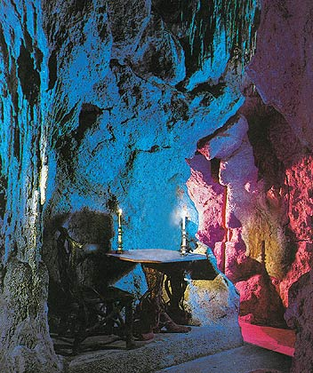
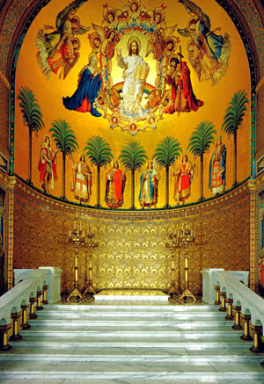
On the opposite side the castle, accessible through a painted marble portal in the lower hall, lies one of its most prominent rooms in the entire Palace. This room known as the Throne Room or more commonly as the Throne Hall and is the most lavishly decorated room in the entire castle. The room itself is massive, taking up the entire west section of the Palace on the both the third and fourth floors (Bavarian Department of State-owned Palaces, Gardens and Lakes). It is done in the Byzantine style and incorporates features inspired by the All Saint’s Church in Munich. This church was itself based on the Hagia Sophia in Istanbul, so Neuschwanstein castle’s Throne Hall has its roots in this famous structure.
Figure 6-Image of the grotto (source: Bavarian Department of State-owned Palaces, Gardens and Lakes Official Site)
The length and symmetry of the room is intended to draw a viewer’s eyes to the cupola at the far side (fig. 7). This dome was painted with representatives of pre-Christian kingdoms. The apse depicts Christ, the twelve apostles, and the six holy knights (Steinberger 88). These images are framed with a ring of stars above. Beneath this, Ludwig intended to place an intricately carved throne faced with bronze and ivory and worked in relief, which was to serve as the focal point of the room. This throne was never built, however, since the Court Secretariat refused to issue the commission for it, possibly due to the high price of such an item (Bavarian Department of State-owned Palaces, Gardens and Lakes). On the marble floor tiles below where the throne was to be placed, a mosaic depicts the Earth with all of its plants and animals. This transition from the heavenly images above, through the throne, to the Earth and its domain below illustrates Ludwig’s interpretation of Kingship. He believed that kings were not only ordained by god but that they also served as mediators between god and the whole world. The throne was also supposed to serve a second purpose. It would have sat directly beneath the image of Christ, which was the origin point for the murals that flowed out around the rest of the room depicting Parsifal, holy saints, and knights connected to the legend of the Holy Grail. This placement indicates that the throne was to represent the grail, one of the most prominent representations of redemption in Christianity. This duality of the throne is reflective of Ludwig’s mindset when he created Neuschwanstein. His inability to hold on to his power and his defeat in the Austro-Prussian War led him to retreat into dream of the king he wanted to be. This coupled with the wish that he could redeem himself by his virtues alone and once again hold power over his kingdom is immortalized in Neuschwanstein.
Figure 7-Image of the copula of Neuschwanstein's Throne Hall source: (www.ilovecastles.com/neuschwanstein)
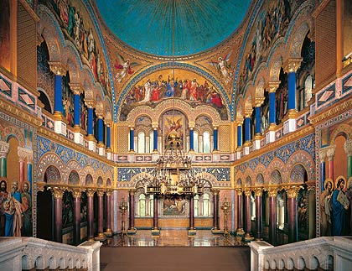
On the west and east ends of the room there are two-story galleries that are arcaded on both levels (fig.8). Due to the heavy load on these features, the columns and the arcades they support were not fashioned out of stone; instead they were cast in iron. The iron was then encased in porphyry and lapis-lazuli stucco. The architects had originally planned to have two copulas over the two story arrangements of columns but Ludwig insisted on the single copula at the center of the room (Bavarian Department of State-owned Palaces, Gardens and Lakes). Hanging from the ceiling an ornate chandelier made of gold plated brass provides a means of lighting the room. This chandelier is supported by a network of iron girders in the ceiling, similar to the one used to support the dome, because of its weight and the distance it hangs from the ceiling.
Figure 8-Image of the Throne Hall from the perspective of the copula. (source: Bavarian Department of State-owned Palaces, Gardens and Lakes Official Site)
Most of the rest of the Palace features hand carved wooden furniture and murals depicting figures from Wagner’s operas. The second floor of the castle was unfinished at the time the castle was first open to the public and as such contains very little of the ornamentation it was intended to have.
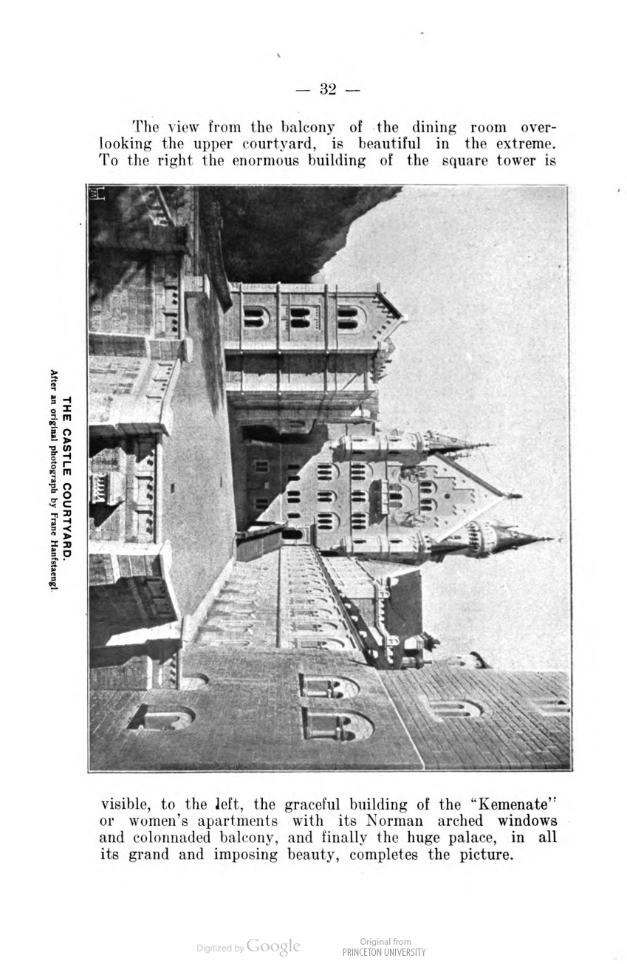
Outside the palace lies the expansive two-level courtyard made entirely of stone and marble. Broad marble steps then lead from the upper to the lower courtyard. The knights building, which connects the Palace to the gatehouse and is joined on its south side to the Ladies Bower, forms the outline of this multilevel courtyard (fig.9). Alcoves and balconies from the buildings around the courtyard jut at regular intervals to overlook it. From these buildings small corner towers also emerge. On the north side of the castle a 65m tall tower was also built. It was topped with a gallery that had a stone balustrade running around it. Above this lies a cornice with battlements out of which a small side tower projects (Steinberger 33). A large two-story high loggia, with roofs of dull gold was also built on the southwest side of the courtyard. It is flanked by smaller round towers placed on the north and south side of the castle. The construction of these towers is very different than that of the tall Square Tower that stands on the north side of the courtyard complex.
Figure 9-Image of the courtyard of Neuschwanstein (source: The royal Bavarian Castles)
The square tower is built in the form of a large rectangle sitting on its edge which becomes a circular tower surrounded by battlements as it nears the top. On the interior the tower is a long circular staircase with a gallery running around the length of it. The building is covered with lean-to roof instead of the slender points that mark the termination of the other towers. The exterior of this tower, like the buildings that surround it, is ornamented with marble squares from Alferschrofen and facades made on Nurtinger sandstone (Steinberger 31). The largest of these facades is on the upper face of the Palace. It depicts a knight enthroned with his shield and spear below the image of the Bavarian heraldic lion.
Across the lower courtyard from the Palace stands the gatehouse. This building is faced in red brick to make it stand out from the rest of the castle and flanked by two small guard towers. The archway of the gate is made of Nurtinger sandstone and bears the Bavarian coat of arms on its apex (Steinberger 32). Ludwig had originally planned for the gate complex to include a drawbridge over the cleft that was made in the rock of the hill when it was being leveled by blasting, but it was never built. Instead the gap is spanned by a stone bridge. On the interior of the gateway arch lays the door to the porter’s lodge. Above the door to this room is a stone figure of a dog (the symbol of fidelity) and the inscription, “Bei Tag und Nacht die Treue wacht”, (Faithfulness keeps watch by day or night).
Adjoining the porter’s lodge on the interior of the gatehouse is a kitchen and a stairway leading to the first floor. The kitchen on this floor was primarily used to prepare Ludwig’s meals during the short time he lived at the castle (Knapp 11). He would then eat his meals in a Royal dining hall constructed near the landing of the staircase on the first floor. This room is dominated by a large hand carven wood table surrounded by chairs of the same make. A high backed carved wooden sofa sits at the end of the room. Cushions covered with pressed leather cover the wood to provide comfort. Around the room, paintings and murals depict the growth of a young boy to a man in a romanticized version of the middle ages. The most prominent painting in this series is that of a knight who is about to engage in a tournament. The symbolism in this room shows Ludwig’s fascination in the stories of old and his belief that he was cut from a similar mold as the brave knight who was to risk his life.
Through a doorway leading out of this room lies the king’s temporary bedchamber. This room unlike the one in the Palace was not richly decorated since it was designed merely as a temporary lodging for the king as he overlooked the construction of his castle (Bavarian Department of State-owned Palaces, Gardens and Lakes).

History of Neuschwanstein after Construction:
Seven weeks after Ludwig died; Neuschwanstein was opened to the public as a tourist attraction. The castle quickly became the largest source of income for the Bavarian Royal Family ( Bavarian Department of State-owned Palaces, Gardens and Lakes). Even though the castle was constructed to serve as a refuge for a single hermit thousands of people were taken with its unique construction and its idyllic location.
In 1918, ownership of the castle was transferred to the state as a part of the socialization of the civil lists that occurred as Bavaria was transferring its government from a monarchy to a Republic. The state placed the management and upkeep in the hands of the Bavarian Palace Department, which still manages the castle to this day. As the years passed after this transfer the castle’s popularity continued to increase. By 1939, two hundred-thousand people visited it annually ( Bavarian Department of State-owned Palaces, Gardens and Lakes). This tourism dropped off abruptly, however, over the course of World War I and World War II. Fortunately, the castle managed to survive these conflicts untouched because of its secluded location.
During the Second World War ownership of the castle fell to the Einsatzstab Reichsleiter Rosenberg für die Besetzen Gebiete (Reichsleiter Rosenberg Institute for the Occupied Territories), which was a sub organization of the Nazi Party. This organization used the castle as a depot for Nazi plunder from France. The works of art were catalogued photographically and these photos were placed in albums so that the location of each piece of art could be easily identified. After the war, 39 photo albums were found in the palace, documenting the dimension and extent of the treasures stored at Neuschwanstein (National Archives). The albums are now stored in the United States National Archives.
Due to Neuschwanstein being used as a repository for stolen artifacts, the SS considered blowing up the castle to prevent the building itself and the artwork it contained from falling to the Allies. The plan was not carried out by the SS-Gruppenführer who was assigned the task, and so the castle was surrendered undamaged to representatives of Allied Forces (Linnenkamp 28).
Throughout the years following the World Wars, Neuschwanstein’s fame grew. It was featured in the movies Ludwig II, Ludwig, and Chitty Chitty Bang Bang as well as being the inspiration for Walt Disney’s Sleeping Beauty's Castle in Disneyland ( Bavarian Department of State-owned Palaces, Gardens and Lakes).The castle also became the motif of a West German definitive stamp and appeared on a €2 commemorative coin for the German Bundesländer series in 2012. A meteorite that reached Earth on April 6, 2002 at the Austrian border near Hohenschwangau was also named Neuschwanstein after the castle (Kohout, Cheron and Donadini). For all of its fame the castle was still never added to the list of UNESCO World Heritage Sites.
Today the castle is visited by 1.4 million people annually and about 6,000 visitors a day in the summer. The Palace of the castle can only be entered on set 30 minute guided tours that focus different parts of the caste’s history. The second floor of the Palace has also been filled in with a visitor’s center featuring a café, a video room used to show movies on the life and death of Ludwig, a large bookshop, and a gift shop (Knapp 13).
There are some issues that are currently of concern at Neuschwanstein. The biggest of these is the constant shifting movement in the foundation area that has to be continuously monitored (Bavarian Department of State-owned Palaces, Gardens and Lakes). The sheer rock walls must also be repeatedly secured to prevent sections of the castle from being taken away in a rockslide. The probable reason for this uncertainty in the rock on which Neuschwanstein sits is likely linked to the sheer strain placed upon it from the collision of the African and Eurasian tectonic plates which determined much of the geology in the area (Froitzheim). Another reason is likely to be the stress applied when the rock was blast leveled. The harsh climate of Southern Bavaria has also damaged the limestone façades, which will have to be constantly repaired in the years to come.

Conclusion:
The castle of Neuschwanstein in Southern Bavaria is one of the greatest architectural marvels of the world. It was the creation of the defeated king, Ludwig II, in a time when most of his power had been taken from him. It was to be his refuge and a place where he could immerse himself in old German legends and the works of his idol, Richard Wagner, that had so colored his childhood. In order to construct this vision, Ludwig’s architects had to use the most modern innovations in building materials and practices available. They even outfitted the castle with all the modern luxuries that were available at the time. This focus on function, however, did not take away from the form of the castle. From the resplendent Throne Hall to the majestic beauty of the indoor grotto, Neuschwanstein incorporates architectural features that range from the astounding to the mystical. Unfortunately, Ludwig never saw his creation completed as he died before the castle was finished. Neuschwanstein outlasted him though. It survived the feet of thousands of tourists and two world wars to become what it is today, the best modern representation of Medieval Romanticism style of architecture. The castle has also made a lasting impression on the world in the form of movies and as the inspiration for Walt Disney’s Sleeping Beauty Castle in Disneyland. Although, Neuschwanstein is now encountering dangers posed by a shifting foundation and the harsh Bavarian weather it is being monitored and repaired so that it can be enjoyed by generations to come. Visiting Neuschwanstein leaves a visitor with the feeling that they walked through an opera composed by a man seeking to create a life beyond the bounds of reality. In this way it seems that Ludwig was able to emulate his greatest idol by crafting an opera not of words but of stone and iron.

Works Cited

Bavarian Department of State-owned Palaces, Gardens and Lakes. The Neuschwanstein Castle. Munich: Bavarian Department of State-owned Palaces, Gardens and Lakes, 2013. Web. 30 November 2013
Bavarian Department of State-owned Palaces, Gardens and Lakes. King Ludwig II of Bavaria. Biography. Munich: Bavarian Department of State-owned Palaces, Gardens and Lakes, 2013. Web. 30 November 2013
—. Tour of the Castle. Munich: Bavarian Department of State-owned Palaces, Gardens and Lakes, 2013. Web. 30 November 2013
Encyclopedia Britanica. "Louis II." Biography. n.d. Web.
Froitzheim, Nikolaus. Geology of the Alps Part 1: General remarks; Austroalpine nappes. Lecture outline. Bonn: University of Bonn , n.d. Pdf.
King, Greg. The Mad King: The Life and Times of Ludwig II of Bavaria. Biography. Secaucus, New Jersey: Carol Publishing Group, 2010. Web. 30 November 2013
Knapp, Gottfried. Neuschwanstein. Trans. Joachim Baun. London: Edition Axel Menges, 1999. Print.
Kohout, T., et al. The possible scenarios of the Neuschwanstein meteorite history based on physical properties. Meeting Abstract. Washington DC: NASA, 2004. Web. 30 November 2013
Linnenkamp, Rolf. Die Schlösser und Projekte Ludwigs II. Heyne Verlag, 1986. Pdf.
National Archives. National Archives Announces Discovery of "Hitler Albums" Documenting Looted Art. Press Release. Washington DC: National Archives, 2007. Web. 30 November 2013
Notable Name Database. "Ludwig II." Biography. n.d. Web. 30 November 2013
Steinberger, Hans. The royal Bavarian Castles : Herren-Chiemsee, Neuschwanstein, Hohenschwangau, Linderhof,and Berg. Munich: F. Speiser, 1905. Pdf.

