Packet Tracer – IPv6 Dynamic Routing – OSPFv3
Topology
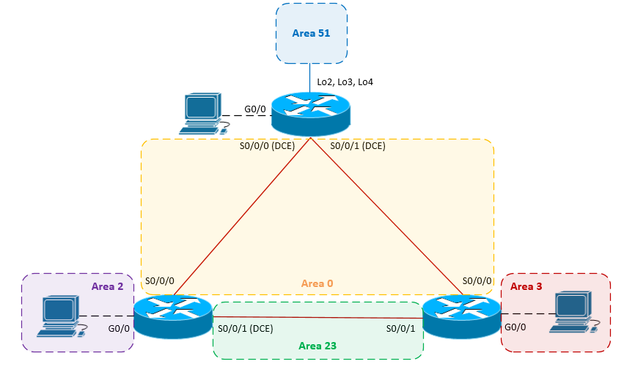
Scenario
NetVise Corporation found it too tedious to manage multiple IPv6 static routes across their growing infrastructure. The CEO has requested that dynamic routing is implemented to allow the network to scale and provide for simplified routing configurations. Unfortunately, due mergers you have non-Cisco vendor equipment found throughout your network and you will need to use an open standard routing protocol. Your manager has requested that the IPv6 implementation is fully documented and verified.
Prior to starting this lab, your manager provided you with some supporting training material. You are expected to review the provided material thoroughly before starting this lab.

Addressing Table
Device | Interface | Type | IP Address | Area | Prefix | Default Gateway
S1-RTR | S0/0/0 | Global Unicast | 2001:dd41:34:12::1 | 0 | /64 | N/A
 | S0/0/1 | Global Unicast | 2001:dd41:34:13::1 | 0 | /64 | N/A
 | G0/0 | Global Unicast | 2001:dd41:34:1::1 | 0 | /64 | N/A
S1-PC | NIC | EUI-64 |  | 0 | /64 | 2001:dd41:34:1::1
S2-RTR | S0/0/0 | Global Unicast | 2001:dd41:34:12::2 | 0 | /64 | N/A
 | S0/0/1 | Global Unicast | 2001:dd41:34:23::2 | 23 | /64 | N/A
 | G0/0 | Global Unicast | 2001:dd41:34:2::1 | 2 | /64 | N/A
S2-PC | NIC | EUI-64 |  | 2 |  | 2001:dd41:34:2::1
S3-RTR | S0/0/0 | Global Unicast | 2001:dd41:34:13::3 | 0 | /64 | N/A
 | S0/0/1 | Global Unicast | 2001:dd41:34:23::3 | 23 | /64 | N/A
 | G0/0 | Global Unicast | 2001:dd41:34:3::1 | 3 | /64 | N/A
S3-PC | NIC | EUI-64 |  | 3 |  | 2001:dd41:34:3::1

Objectives
- Enable IPv6 routing.
- Configure IPv6 Global Unicast Addresses according to the address table.
- Assign IPv6 addresses statefully using (EUI-64).
- Configure dynamic routing using OSPFv3.
  - Assign router-ids
  - Enable routing on the appropriate interfaces and areas according to the topology
  - Network summarization
- Verify routing and network connectivity.
Task 1: Enable IPv6 routing and assign IPv6 addresses to the appropriate interfaces.

Step 1: Although this step is not required to assign IPv6 addresses to the interfaces, you must enable IPv6 in order to forward IPv6 unicast datagrams (routing).

Step 2: Assign IPv6 global unicast addresses according to the table provided.
Task 2: Assign IPv6 addresses to hosts

Step 1: S1-PC, S2-PC, and S3-PC should be configured using EUI-64 (stateful).
- Open up S1-PC > Config > under IPv6 Configuration select “Auto Config”
- Ensure IPv6 unicast routing is enabled on the directly connected router.
- Document host configuration and ping the default gateway.

Task 2: Configure dynamic routing using OSPFv3

Step 1: Assign the appropriate router-ids to each router, create a loopback for each /32 address.
- S1-RTR: 1.1.1.1
- S2-RTR: 2.2.2.2
- S3-RTR: 3.3.3.3

Step 2: Enable OSPFv3 routing for all appropriate interfaces according to the address table.

Step 3: Summarize the following networks sourcing from S1-RTR to both S2-RTR and S3-RTR.
- Create the following loopbacks on S1-RTR, enable them for OSPF within Area 51.
  - Lo1: 2001:dd41:34:51::1/64
  - Lo2: 2001:dd41:34:52::1/64
  - Lo3: 2001:dd41:34:53::1/64

NOTE: As of July, 2013 summarization cannot be configured in packet tracer 6.0.1 for OSPFv3.

Task 3: Configure dynamic routing using OSPFv3

Step 1: Verify all routes have been successfully advertised.

Step 2: Verify reachability from all hosts within different OSPF areas.

NOTE: As of July, 2013 during testing some routing inconsistencies existed when working with multiple areas.

