Packet Tracer – IPv6 - Skills Integration Challenge

Topology
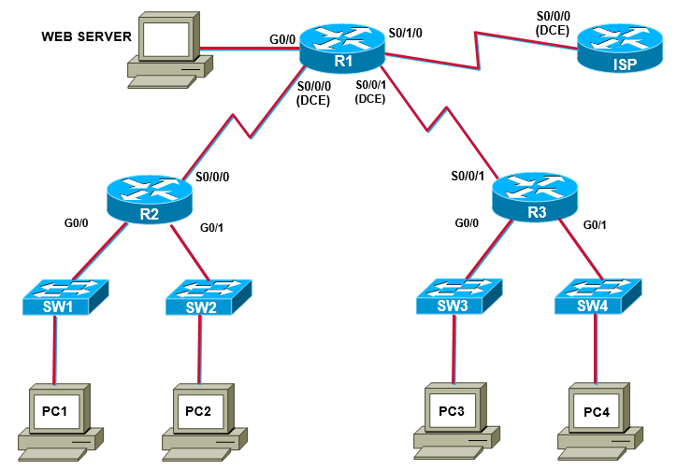
Scenario
NetVise Corporation has agreed to allow the network engineering team to design and integrate an IPv6 network based on their previous pilot configurations. However, the network must go into production immediately in order to resume business operations. You should complete this skills integration challenge within a 1 hour timespan.
Prior to starting this lab, your manager provided you with some supporting training material. You are expected to review the provided material thoroughly before starting this lab.

Addressing Table
Device | Interface | Type | IP Address | Prefix | Default Gateway
ISP | S0/0/0 | Global Unicast
R1 | S0/0/0 | Global Unicast
 | S0/0/1 | Global Unicast
 | S0/1/0 | Global Unicast
 | G0/0 | Global Unicast
R2 | S0/0/0 | Global Unicast
 | G0/0 | Global Unicast
 | G0/1 | Global Unicast
R3 | S0/0/0 | Global Unicast
 | G0/0 | Global Unicast
 | G0/1 | Global Unicast
PC1 | NIC | Static
PC2 | NIC | Static
PC3 | NIC | EUI-64
PC4 | NIC | DHCPv6
Web Server | NIC | Static

Objectives
- Develop hierarchical IPv6 addressing scheme
- Assign interfaces and hosts IPv6 addresses
  - Static
  - EUI-64
  - DHCPv6
- Configure IPv6 dynamic routing using EIGRPv6
- Configure static and default routing to support the network requirements
- Utilize access control lists to restrict web server access

Task 1: Develop hierarchical IPv6 addressing scheme and assign interfaces and hosts IPv6 address appropriately.
Step 1: Your ISP has assigned the global prefix of 2001:acad::/64, given this information you must develop an IPv6 addressing scheme to meet the network requirements. Document all IPv6 address information in the address table provided.

Step 2: Assign network infrastructure interfaces with IPv6 addresses according to the address table and enable IPv6 unicast routing.

Step 3: Assign hosts with IPv6 addresses according to the address table.
- Web server, PC1, and PC2 are all assigned statically, no additional configuration is required besides manually entering the IPv6 address and default gateway in the GUI.
- PC3 should be enabled for stateless autoconfiguration, by selecting “auto-config” for the IPv6 address and default gateway.

- R3 should be configured as a DHCPv6 server to issue IPv6 address information to PC4.
  - Address Prefix: 2001:acad:0:32::/64
  - Domain Name: netspace.com
  - DNS Server: 2001:4860:4860::8888
Task 2: Configure IPv6 dynamic routing using EIGRPv6
Step 1: Enable EIGRPv6 and assign router-ids, use an autonomous system number of your choosing.
- R1 – 1.1.1.1/32 Lo0
- R2 – 2.2.2.2/32 Lo0
- R3 – 3.3.3.3/32 Lo0

Step 2: Enable the appropriate interfaces for EIGRPv6 to allow for full reachability.

Step 3: Summarize networks coming from R2 LAN interfaces.

Task 3: Configure static and default routing to support the network requirements
Step 1: Redistribute default route into the EIGRP process for R2 and R3 to reach the internet (ISP).
NOTE: A bug occurs when you attempt create a loopback address for the static default route, it will not show up in the routing table, in this case a physical interface is used, but is against best practice.

Step 2: Configure a default static route on the ISP Router to allow full reachability.
Task 4: Utilize access control lists to restrict web server access
Step 1: Create an ACL that blocks HTTP and FTP traffic sourcing from PC1 and PC2 and permits all other traffic from any sources.

